

# Perth Modern School

### Semester Two Examination, 2018

### Question/Answer Booklet

# MATHEMATICS

**METHODS**

## 

## Section Two:

## Calculator-assumed

Student’s Name : **MARKING KEY**

Your Teacher’s name

## Time allowed for this section

Reading time before commencing work: ten minutes

Working time for section: one hundred minutes

## Materials required/recommended for this section

***To be provided by the supervisor***

This Question/Answer Booklet

Formula Sheet (retained from Section One)

***To be provided by the candidate***

Standard items: pens (blue/black preferred), pencils (including coloured), sharpener, correction fluid/tape, eraser, ruler, highlighters

Special items: drawing instruments, templates, notes on two unfolded sheets of A4 paper, and up to three calculators approved for use in the WACE examinations

## Important note to candidates

No other items may be taken into the examination room. It is **your** responsibility to ensure that you do not have any unauthorised notes or other items of a non-personal nature in the examination room. If you have any unauthorised material with you, hand it to the supervisor **before** reading any further.

|  |  |  |  |  |  |  |
| --- | --- | --- | --- | --- | --- | --- |
| Q8 | Q9 | Q10 | Q11 | Q12 | Q13 | Q14 |
| 11 | 4 | 7 | 7 | 6 | 3 | 9 |
| Q15 | Q16 | Q17 | Q18 | Q19 | Q20 | TOTAL |
| 8 | 8 | 8 | 12 | 8 | 7 |  |

## Structure of this paper

|  |  |  |  |  |  |
| --- | --- | --- | --- | --- | --- |
| Section | Number of questions available | Number of questions to be answered | Working  time (minutes) | Marks available | Percentage of exam |
| Section One:  Calculator-free | 7 | 7 | 50 | 50 | 35 |
| Section Two:  Calculator-assumed | 13 | 13 | 100 | 100 | 65 |
|  | | | **Total** | 150 | 100 |

## Instructions to candidates

1. The rules for the conduct of examinations are detailed in the school handbook. Sitting this examination implies that you agree to abide by these rules.
2. Write your answers in this Question/Answer Booklet.
3. You must be careful to confine your response to the specific question asked and to follow any instructions that are specified to a particular question.
4. Spare pages are included at the end of this booklet. They can be used for planning your responses and/or as additional space if required to continue an answer.

* Planning: If you use the spare pages for planning, indicate this clearly at the top of the page.
* Continuing an answer: If you need to use the space to continue an answer, indicate in the original answer space where the answer is continued, i.e. give the page number. Fill in the number of the question that you are continuing to answer at the top of the page.

1. **Show all your working clearly**. Your working should be in sufficient detail to allow your answers to be checked readily and for marks to be awarded for reasoning. Incorrect answers given without supporting reasoning cannot be allocated any marks. For any question or part question worth more than two marks, valid working or justification is required to receive full marks. If you repeat any question, ensure that you cancel the answer you do not wish to have marked.
2. It is recommended that you **do not use pencil**, except in diagrams.
3. The Formula Sheet is **not** to be handed in with your Question/Answer Booklet.

Section Two: Calculator-assumed 65% (100 marks)

This section has**thirteen (****13)** questions. Answer **all** questions. Write your answers in the spaces provided.

Working time for this section is 100 minutes.

Question 8 (11 marks)

The cash balance C (in thousands of dollars) for the first few months of a start-up company vary according to the function $C={-e}^{0.1t}sin(t)$, where t represents months. **Hint: Use radians.**

(a) State the first and second derivatives of the cash balance function. (3 marks)

|  |
| --- |
| **Solution** |
| $$C=-e^{\frac{t}{10}}Sin\left(t\right)$$ $$\frac{dC}{dt}=-e^{\frac{t}{10}}\left(\frac{Sin\left(t\right)}{10}+Cos\left(t\right)\right)$$ $$\frac{d^{2}C}{dt^{2}}=-\frac{1}{100}e^{\frac{t}{10}} \left(20 Cos\left(t\right)-99 Sin\left(t\right)\right)$$ |
| **Specific behaviours** |
| ✓ states first derivative  ✓✓ states second derivative |

(b) State when in the first year when either the cash balance function equals zero or its first derivative equal zero. (3 marks)

|  |
| --- |
| **Solution** |
| Cash Balance is zero at 3.14, 6.28, 9.42  Stationary Points at 1.67, 4.81, 7.95, 11.09 |
| **Specific behaviours** |
| ✓ identifies when cash balance is zero  ✓identifies stationary point  ✓ states all second derivative |

(c) Sketch the cash balance equation on the set of axes. (3 marks)

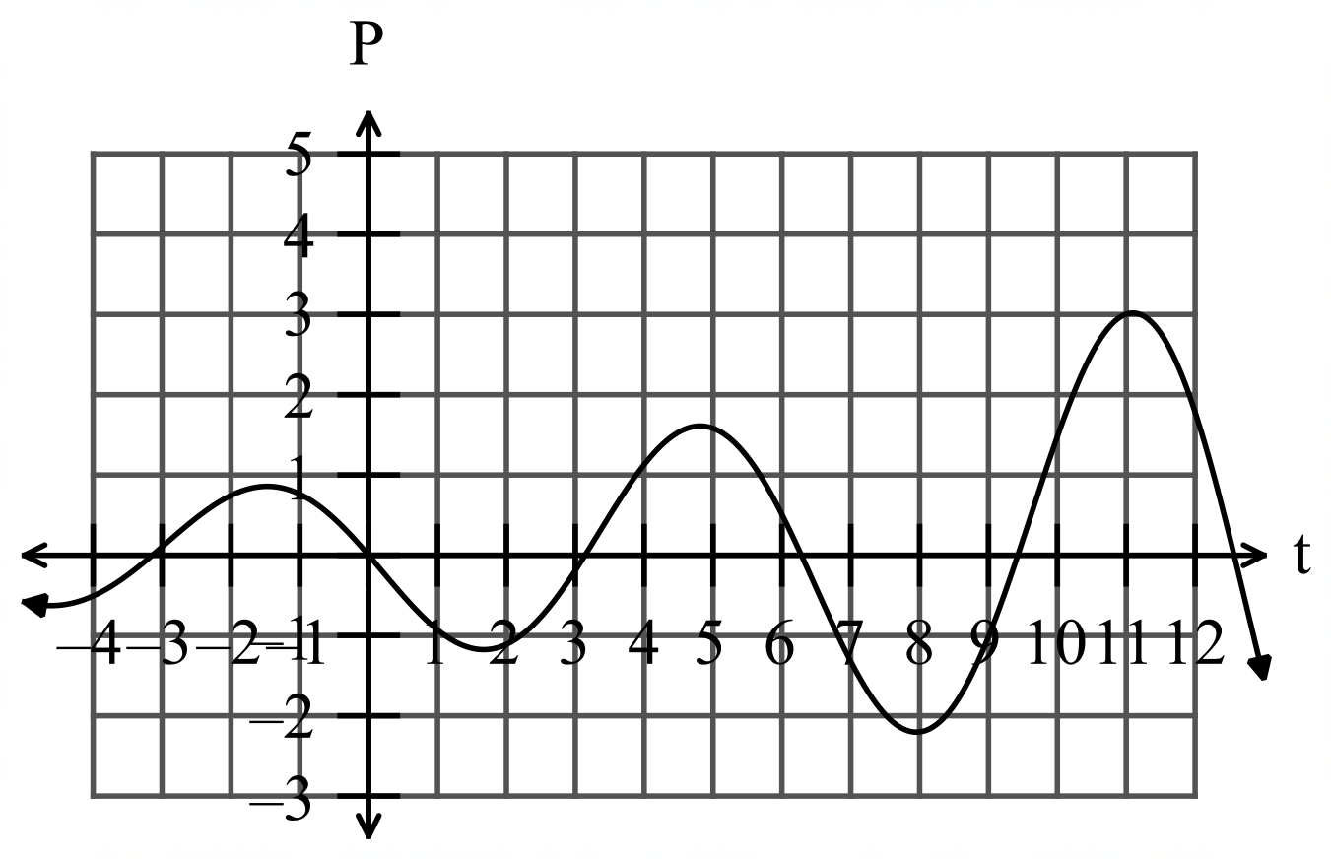

After the first five months, the owner employed more staff and it took a little while for sales to start to increase again.

(d) Determine when the cash balance started to increase again. (1 mark)

|  |
| --- |
| **Solution** |
| Cash starts to increase after 7.95 months |
| **Specific behaviours** |
| ✓ identifies when cash balance begins to increase |

(e) Determine when the cash balance become positive again. (1 mark)

|  |
| --- |
| **Solution** |
| Cash Balance become positive after 9.42 months |
| **Specific behaviours** |
| ✓ identifies when cash balance returns to positive |

Question 9 (4 marks)

Michelle collected comic book trading cards from two brands, Marvel and DC. She has eight (8) Marvel cards and twelve (12) DC cards. She shuffles the cards in a deck.

One card is selected, and its brand colour noted then it is replaced in the deck and mixed thoroughly with the other cards again. This process is repeated several times.

(a) What is the probability that the first DC card drawn is the third card? (2 marks)

|  |
| --- |
| **Solution** |
| $$\frac{8}{20}=\frac{2}{5}$$ |
| **Specific behaviours** |
| ✓ identifies probability  ✓ Simplifies ratios |

Up to three cards can be drawn. The draw stops once a DC card is selected.

(b) What is the probability that a DC card is not drawn? (2 marks)

Question 10 (7 marks)

Australian population in 1880 was 2,231,489.

The population in 1930 had grown to 6,501,012.

1. Taking $t=0$ in 1880, set up an equation in the form $P=P_{0}e^{kt}$ that can be used to estimate the population growth during the 50-year period. (2 marks)

(b) Write down the average annual population growth over that period. (1 mark)

Over the next 60 years to 1990, the population grew to 17,169,181.

(c) Determine if the rate of growth during the 60 years from 1930 to 1990 is the same as the rate of growth from 1880 to 1930. (2 mark)

(d) Use the data from 1930 to 1990 to predict the taxable income in 2016. (2 mark)

NB. Australia’s population in 2016 was 24,129,300.

Question 11 (10 marks)

1. (i) Find the expected value and variance of the probability density function in the table below. (5 marks)

|  |  |  |  |  |
| --- | --- | --- | --- | --- |
| *x* | 1 | 2 | 3 | 4 |
| *P*(*X = x*) | 0.3 | 0.2 | 0.2 | 0.3 |

(ii) The values of setare transformed so that 

Write down the expected value and variance of set  (2 marks)

(b) Fiona bet on the outcome of an unfair 4 sided tetrahedral die with probabilities as in the table below.

|  |  |  |  |  |
| --- | --- | --- | --- | --- |
| *x* | 1 | 2 | 3 | 4 |
| *P*(*X = x*) | 0.3 | 0.2 | 0.2 | 0.3 |

It costs Fiona $1 per spin and the payout is $2 for a 2 or a 3 and nothing otherwise.

What is Fiona’s average payout? (3 marks)

Question 12 (6 marks)

The “ruff and muddy race” organisers arranged for 250 cross country runners to compete in an endurance race. They have identified that a particularly steep section of race needs a maximum safe running speed of 12kmh-1 to avoid the risk of injury to the competitors. During the race the organisers measure the speed of runners through the section and calculate that runners had a mean and standard deviation of 11.4 kmh-1 and 0.8 kmh-1 respectively. A summary of the data is shown in the table below.

|  |  |  |  |  |  |
| --- | --- | --- | --- | --- | --- |
| Speed ( kmh-1) |  |  | 11 | 12 | 13 $≤x<14$ |
| Relative frequency | 0.024 | 0.272 | 0.504 | 0.188 | 0.012 |

(a) Use the table of relative frequencies to estimate the probability that the next runner on that section

(i) was not exceeding the speed limit. (1 mark)

|  |
| --- |
| **Solution** |
| $$0.024+0.272+0.504=0.8$$ |
| **Specific behaviours** |
| ✓ states probability |

(ii) had a speed of less than 13 kmh-1, given they were exceeding the speed limit.

(1 mark)

|  |
| --- |
| **Solution** |
| $$0.024+0.272+0.504=0.8$$ |
| **Specific behaviours** |
| ✓ states probability |

(b) Subsequent tests on the measuring equipment discovered that it had been wrongly calibrated. The correct speed of each runner, $v$, could be calculated from the measured speed, $x$, by increasing $x$ by 6% and then adding 1.7kmh-1.

(i) Calculate the adjusted mean and standard deviation of the runners’ speeds.

(2 marks)

|  |
| --- |
| **Solution** |
| $$\overline{v}=56.9×1.06+1.7≈62.0 {\text{kmh}}^{-1} \\ sd_{v}=3.6×1.06≈3.82 {\text{kmh}}^{-1}$$ |
| **Specific behaviours** |
| ✓ calculates new mean  ✓ calculates new sd |

(ii) Determine the correct proportion of runners exceeding 6kmh-1. (2 marks)

|  |
| --- |
| **Solution** |
| $6.0=x×1.06+1.7⇒x=5.5$ Hence $0.504+0.188+0.012=0.704$ is correct proportion. |
| **Specific behaviours** |
| ✓ determines  ✓ states proportion |

Question 13 (3 marks)

A lottery sells 1000 tickets and claims that there will be 10 winners. How many tickets should you buy so that you have a 20% chance of winning at least 1 prize.

**Question 14 (9 marks)**

The simulation of a loaded (unfair) spinner is spun 60 times and the results recorded with the following results. (Below diagram is for illustrative purposes only)

|  |  |
| --- | --- |
| **Result** | **Count** |
| 1 | 5 |
| 2 | 20 |
| 3 | 15 |
| 4 | 15 |
| 5 | 5 |

(a) Calculate the proportion of even numbers recorded in this simulation. (2 mark)

(b) Determine the mean and standard deviation for the sample proportion of even numbers in 60 tosses, using the results above. (2 marks)

(c) It has been decided to create a confidence interval for the proportion of even numbers using the simulation results. The level of confidence will be chosen from 90% or 95%. Explain which level of confidence will give the smallest margin error. State the margin of error. (3 marks)

This simulation of 60 spins of the spinner is performed another 200 times, with the proportion of even numbers recorded each time and graphed.

(d) Comment briefly on the key features of this graph. (2 marks)



**Question 15 (8 marks)**

From a random sample of $n$ people, it was found that 540 of them watch the AFL grand final.

A symmetric confidence interval for the true population proportion who watched the grand final is $0.1842<p<0.2958$.

(a) Determine the value of $n$, by first finding the mid-point of the interval. (4 marks)

|  |
| --- |
| **Solution** |
| $$\frac{0.1842+0.2958}{2}=0.24 \\ p=0.24=\frac{540}{n} \\ n=540÷0.24=2 250$$ |
| **Specific behaviours** |
| ✓ calculates mid-point  ✓ writes equation using mid-point for  ✓ determines $n$ |

(b) Determine the confidence level of the interval. (4 marks)

|  |
| --- |
| **Solution** |
| Standard error: $\sqrt{\frac{0.24×\left(1-0.24\right)}{225}}=0.02847$ $0.24+z×0.02847=0.2958$ $z=1.96$   Hence a 95% confidence interval |
| **Specific behaviours** |
| ✓ calculates standard error  ✓ uses interval formula  ✓ determines z-score  ✓ states confidence level |

Question 16 (8 marks)

The moment magnitude scale $M_{w}$ is used by seismologists to measure the size of earthquakes in terms of the energy released. It was developed to succeed the 1930's-era Richter magnitude scale.

The moment magnitude has no units and is defined as $M_{w}=\frac{2}{3}\log_{10}\left(M_{0}\right)-10.7$, where $M_{0}$ is the total amount of energy that is transformed during an earthquake, measured in dyn $∙$ cm.

(a) On 21 December 1937, an estimated $6.31×{10}^{13}$ dyn∙cm of energy was transformed during an earthquake in the Simpson Desert in NT. Calculate the moment magnitude for this earthquake.

(2 mark)

|  |
| --- |
| **Solution** |
| $$M_{w}=6.0$$ |
| **Specific behaviours** |
| ✓ calculates MM |

(b) A few years later, on 27 July 1941, there was another earthquake with moment magnitude 6.5 in the Simpson Desert. Calculate how much energy was transformed during this earthquake. (2 marks)

|  |
| --- |
| **Solution** |
| $$6.5=\frac{2}{3}\log_{10}{x}-10.7 \\ x=7.08×{10}^{23} \text{dyn}∙\text{cm}$$ |
| **Specific behaviours** |
| ✓ substitutes  ✓ solve for energy |

(c) Show that an increase of 2 on the moment magnitude scale corresponds to the transformation of 1000 times more energy during an earthquake. (4 marks)

|  |
| --- |
| **Solution** |
| $$M_{w}=\frac{2}{3}\log_{10}\left(x\right)-10.7…\left(1\right) \text{and }M_{w}+2=\frac{2}{3}\log_{10}\left(y\right)-10.7…(2)$$ $$\left(2\right)-\left(1\right):2=\frac{2}{3}(\log_{10}{y}-\log_{10}{x})$$ $$\log_{10}{\frac{y}{x}}=3$$ $$\frac{y}{x}={10}^{3}=1000 \text{times greater}$$ |
| **Specific behaviours** |
| ✓ writes two equations for $M$ and  ✓ subtracts equations  ✓ uses log laws to simplify  ✓ converts to exponential form and simplifies  *NB Max ✓✓ if uses specific values rather than general case* |

**Question 17 (8 marks)**

A particle, initially stationary and at the origin, moves subject to an acceleration, ms-2, as shown in the graph below for $0≤t≤20$ seconds.

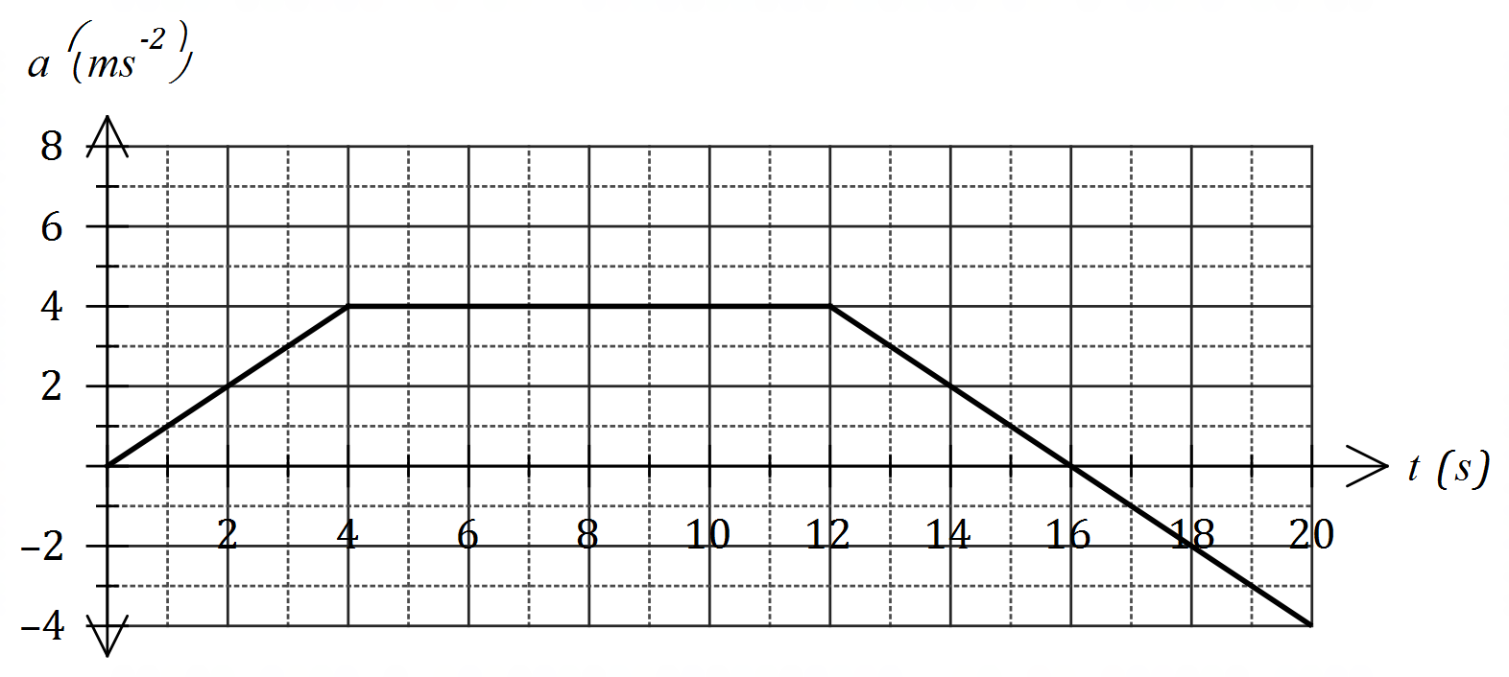

(a) Determine the velocity of the object when

(i) $t=4$ (1 mark)

|  |
| --- |
| **Solution** |
| $$v=\frac{1}{2}×6×6=18 \text{m/s}$$ |
| **Specific behaviours** |
| ✓ calculates area |

(ii) $t=12$ (1 marks)

|  |
| --- |
| **Solution** |
| $$v\left(12\right)=18+18-2-12=36-14=22 \text{m/s}$$ |
| **Specific behaviours** |
| ✓ calculates area above axes |

(iii) $t=20$ (1 marks)

|  |
| --- |
| **Solution** |
| $$v\left(20\right)=18+18-2-12=36-14=22 \text{m/s}$$ |
| **Specific behaviours** |
| ✓ calculates area below axes and subtracts from area above |

(b) At what time is the velocity of the body a maximum, and what is the maximum velocity?

(2 marks)

|  |
| --- |
| **Solution** |
| When $t=16$ seconds, $v_{MAX}=36$ m/s |
| **Specific behaviours** |
| ✓ identifies time ✓ states maximum velocity |

(c) Determine the displacement of the particle from the origin after $20$ seconds. (3 marks)

|  |
| --- |
| **Solution** |
| $$a=t⇒v=\frac{t^{2}}{2}⇒x=\frac{t^{3}}{6}$$ $$x\left(3\right)=\frac{27}{6}=4.5 \text{m}$$ |
| **Specific behaviours** |
| ✓ expresses $a$ in terms of  ✓ integrates twice to obtain displacement  ✓ uses $t=3$ to calculate displacement |

Question 18 (12 marks)

The potassium level in a population of people has a normal distribution with a mean of 4.4 units and a standard deviation of 0.45 units.

A healthy person (from a potassium point of view) has a standardised reading, *z*, where  .

(a) Determine the potassium bounds of a healthy person. (2 marks)

(b) Determine the probability that a randomly selected person:

1. is considered healthy. (1 mark)

(ii) has a reading of less than 3.5 (1 mark)

(iii) has a reading of more than 3.5, if it is known to be less than 5. (2 marks)

(c) Of the next ten people tested, determine the probability that:

(i) they are all healthy. (1 mark)

(ii) the first unhealthy person is the fifth person tested. (2 marks)

(iii) exactly five are healthy. (1 mark)

(d)A sample of one hundred people are tested for potassium. Determine the probability that the mean of the sample is less than 4.3 units. (2 marks)

Question 19 (8 marks)

Sophie is a petroleum engineer working for Vechron Limited in charge of choosing between two of its sites for the construction of an offshore drilling rig. The government will only allow drilling of one site.

Sophie is examining recently taken samples for both sites to help with his decision. A sample taken from the first site has a mean sample grade of 4.6 millilitre per cubic metre with a standard deviation of 0.56 mLm-3. Sophie found that the data for the samples are normally distributed.

(a) Determine the probability that a randomly chosen sample contains a grade that is

(i) exactly 4.6 mLm-3. (1 mark)

(ii) greater than 3.5 mLm-3. (1 mark)

(b) Determine the median score. (1 mark)

(c) The probability that another sample contained less than the particular

grade was 0.25 or 25%. Determine the maximum grade for the sample. (1 mark)

The set of samples obtained from the second site has a mean sample grade of 4.7 mLm-3. The data was given to Sophie as a box-plot with the median of 4.72 mLm-3, the lower quartile of 4.2 mLm-3 and the upper quartile of 5.2 mLm-3.

(d) Examine the above statistics to determine if the data for the second

potential site could be represented by a normal distribution.

Justify your conclusion. (2 marks)

(e) Which of the sites would be better for Vechron to drill?

Use your knowledge of statistics and probability to support your choice. (2 marks)

Question 20 (7 marks)

(a) Use your calculator to find the area enclosed between the two functions

 and  as shown in the diagram below.

The points of intersection are shown.

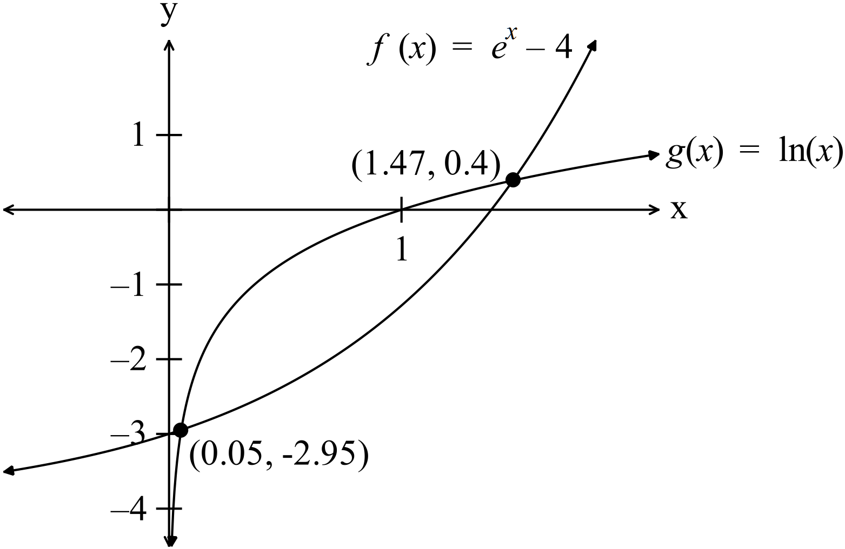 (3 marks)

(b) Keiko is a Biologist studying a bacteria. She has a colony of an experimental bacteria that she is testing for growth characteristics. The population of this colony was studied in over a month. The total population (in millions) can be modelled by the equation  whereis in days starting on 1st September 2018.

(i) What was the population on the 1st of September? (2 marks)

(ii) On what day will the population reach 100 million? (2 marks)

**Additional working space**

Question number: _________

Additional working space

Question number: _________